**ROCKSAT-XN**

**SPARK GAP**

**Assembly Instructions for Flight Model**

M. J. Bailey, S. S. Lawson, M. J. Schwab, J. N. Stefancik, C. A. Romero-Talamás

Dusty Plasma Laboratory

University of Maryland, Baltimore County

1000 Hilltop Circle, Catonsville MD 21250

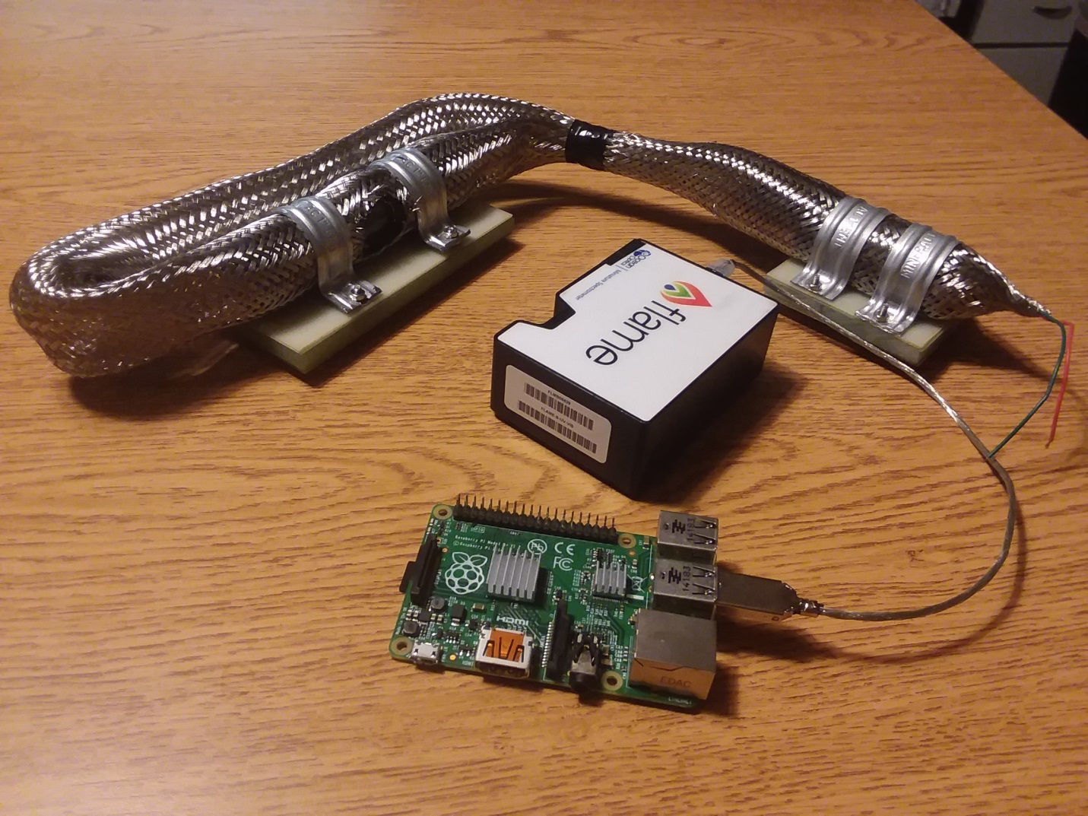UPDATE IMAGES

**Figure 1:** The Completed Spark Gap Device. The device shown is the flight model, ready for mounting on the Aether payload.

# TABLE OF CONTENTS

**Part I –** Acronyms **4**

**Part II –** Parts List **5**

**Part III –** Vendors/Suppliers **7**

**Part IV –** Transformer Assembly **8**

**Part V –** Spark Gap Assembly **12**

**Part VI –** Final Assembly **20**

**Part VII –** Working Drawings **22**

**Part VIII –** Setting Up the Raspberry Pi **23**

**Part IX –** Manufacturing Details **26**

**Part X -** Testing **27**

# Part I

# Acronyms

DPL Dusty Plasma Lab

KPIF Keith Porter Imaging Facility

MMC McMaster-Carr Supply Company

UMBC University of Maryland Baltimore County

# Part II

# Parts List

|  |  |  |  |  |  |
| --- | --- | --- | --- | --- | --- |
| **Part** | **Supplier** | **Supplier**  **ID #** | **DPLX**  **Part #** | **Quantity** | **Assembly Parent** |
| M3X.5mm  SS Hex Nut | MMC | 91828A211 | NA | 8 | 4-Spark Gap  4-Transformer |
| M3X.5mm  SS Phillips Flat Head  12mm | MMC | 92010A122 | NA | 8 | 4-Spark Gap  4-Transformer |
| M3X.5mm  SS Phillips Flat Head  14mm | MMC | 92010A787 | NA | 14 | 8-Spark Gap  6-Transformer |
| Steel Clamp | MMC | 9429T360 | NA | 4 | 2-Spark Gap  2-Transformer |
| Aluminum  Foil Wrap | Giant | N/A | P015 | 1 | Spark Gap |
| Baffle  Inner | Keith Porter Imaging Facility | N/A | P003 | 2 | Spark Gap |
| Baffle  Outer | Keith Porter Imaging Facility | N/A | P004 | 2 | Spark Gap |
| Electrode | UMBC Mechanical Engineering Dept. | N/A | P001 | 2 | Spark Gap |
| Electrode  Set Screw | UMBC Mechanical Engineering Dept. | N/A | P006 | 3 | Spark Gap |
| Ferrite Choke |  |  | NA | 2 | Transformer |
| Quartz Tube | GREATGLAS, Inc. |  | P025 | 1 | Spark Gap |
| Spark Gap Shielding Top |  |  | P029 | 1 | Spark Gap |
| Spark Gap Shielding Middle |  |  | P028 | 1 | Spark Gap |
| Spark Gap Shielding Bottom |  |  | P027 | 1 | Spark Gap |
| Transformer |  |  | P026 | 1 | Transformer |
| VIPE Shielding Top |  |  | P031 | 1 | Transformer |
| VIPE Shielding Middle |  |  | P032 | 1 | Transformer |
| VIPE Shielding Bottom |  |  | P030 | 1 | Transformer |
| Viton Insulation |  |  | P033 | 1 | Spark Gap |
| Viton Insulation |  |  | P034 | 1 | Transformer |
| Wire Shielding | Electriduct |  | N/A | 1 | Spark Gap  Transformer |
| Camera Shroud Mount | UMBC Mechanical Engineering Dept. | N/A | P020 | 1 | Spark Gap |
| Camera Shroud Tube | UMBC Mechanical Engineering Dept. | N/A | P019 | 1 | Spark Gap |

# Part III

# Vendors/Suppliers

* MSC Direct Industrial Company

<https://www.mscdirect.com/>

* McMaster-Carr Supply Company

<https://www.mcmaster.com/>

* Formlabs Inc.

<https://formlabs.com/>

* Keith Porter Imaging Facility

<https://kpif.umbc.edu/>

* UMBC Mechanical Engineering Dept.

<https://me.umbc.edu/>

* GREATGLAS, Inc.

<http://www.greatglas.com/>

* Electriduct, Inc

<https://www.electriduct.com/>

# Part IV

# Transformer Assembly

**Step 1**

* Assemble the G10 shielding
* Insert -92010A122 M3 12mm Screws into the VIPE Insulation Middle Part
* Insert -92010A787 M3 14mm Screws into the VIPE Insulation Middle Part
* 12mm screws face up and will be used to fasten 2 clamps. The 14mm screws will be used to connect this piece to the baseplate.
* 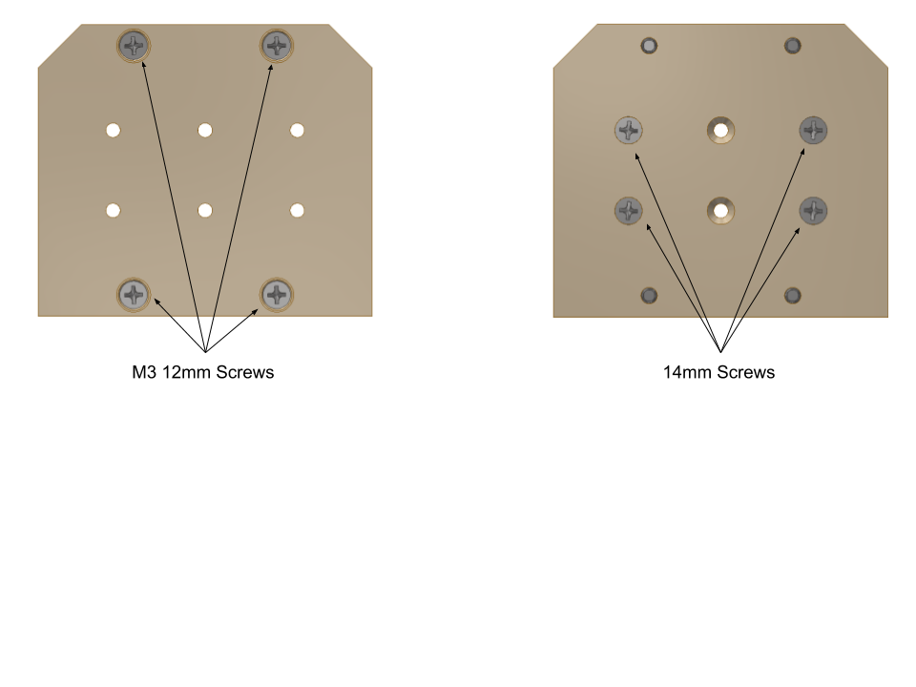12mm Screws are shown in the top and bottom of the picture 14mm are in the center
* These screws must be flush with the surface of the insulating plate, otherwise the assembly could become misshapen.

**Step 2**

* Install the VIPE Insulation Bottom
* Insert the VIPE Insulation Bottom over the 4 screws that are on the bottom of the VIPE Insulation Middle.

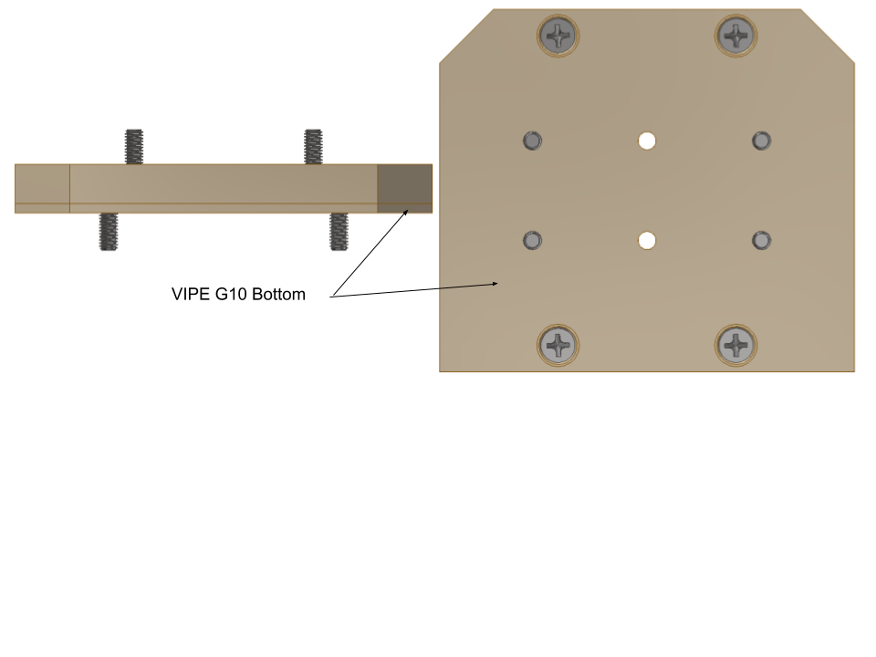

**Step 3**

* Install the Shielding plates to the baseplate.
* The flight baseplate has tapped holes for the screws.
* Attach the 4 screws that pass through the shielding material to the baseplate using one of the two methods explained above. There should be no part of the screw that extends out from the baseplate on the opposite side.

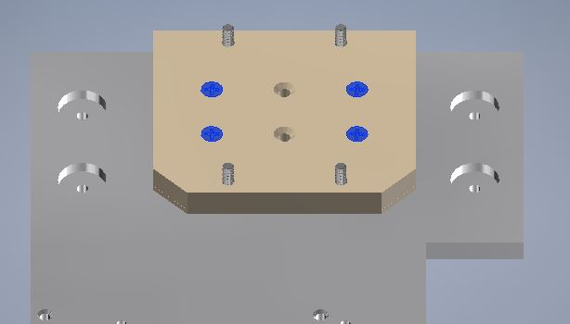

**Step 4**

* Install the VIPE Shielding Top.
* Place the VIPE Shielding Top over the four screws and set this assembly aside in a safe area.

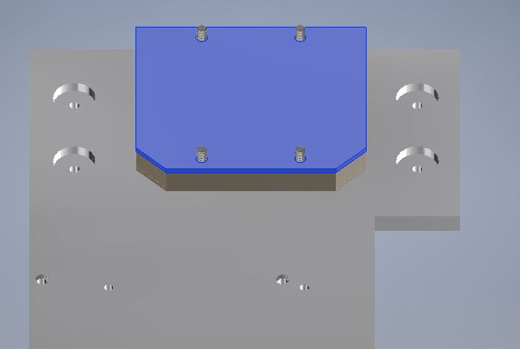

**Step 5**

* Wiring the transformer
* Connect two wires to both ends of the transformer making sure the step up in voltage is going in the correct direction for the transformer you are using.
* These wires should be around 3” long or long enough for you to comfortably solder them to another wire.
* You will have a total of four wires soldered to the transformer now.

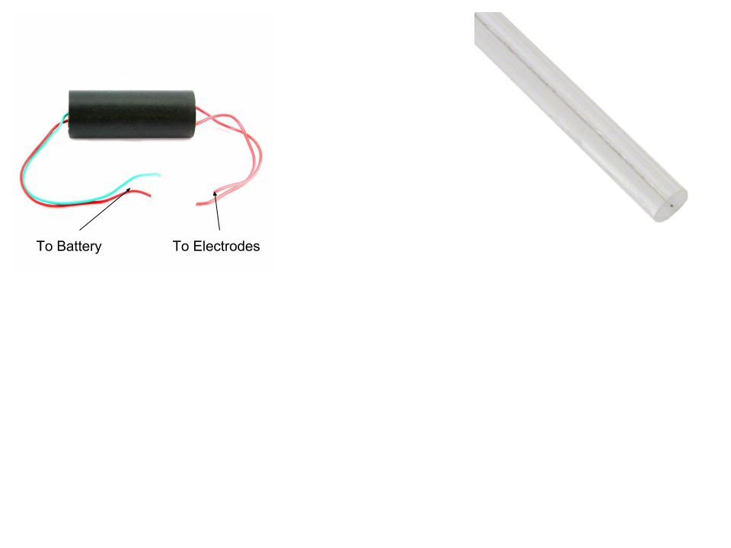

**Step 6**

* Wrap the transformer in .125” Viton
* Wrap the transformer in wire mesh shielding
* Cut a 6”-7” length of the wire mesh shielding.
* Insert the Transformer into the mesh shielding making sure about 1.5” hangs over each end of the Transformer.

**Step 7**

* Fastening the transformer to the G10 shielding.
* Center the transformer on the G10 shielding and using 4- 91828A211 M3 hex nuts and two clamps fasten the transformer to the shielding.

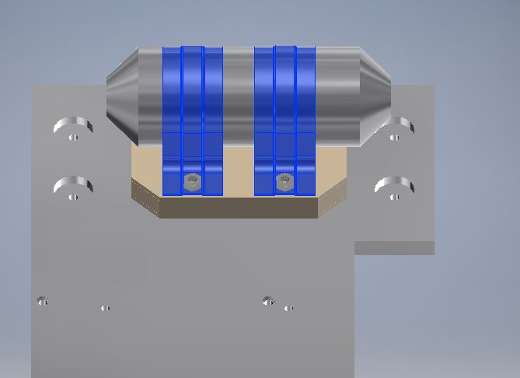

# Part V

# Spark Gap Assembly

**Step 1**

* Assemble the G10 Shielding
* Insert 4-92010A787 M3 14mm Screws into the Spark Gap Insulation Middle Part
* Insert 4-92010A122 M3 12mm Screws into the Spark Gap Insulation Middle Part
* 12mm screws face up and will be used to fasten 2 clamps. The 14mm screws will be used to connect this piece to the baseplate
* Outer screws are 12mm Inner screws are 14mm
* These screws must be flush with the surface of the insulating plate, otherwise the assembly could become deformed.

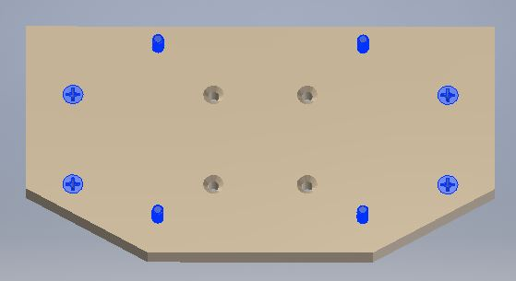

**Step 2**

* Install the Spark Gap Insulation Bottom
* Insert the Spark Gap Insulation Bottom over the 8 screws that are on the bottom of the Spark Gap Insulation Middle.

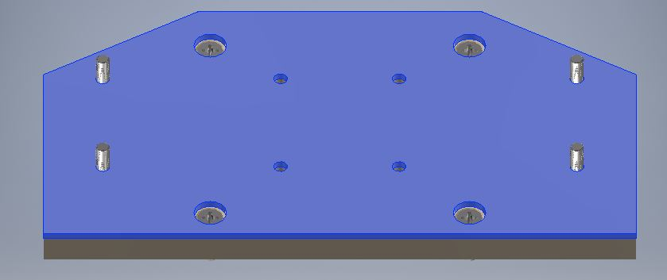

* The Spark Gap Shielding Bottom should fit over the screws easily. If this piece forces any of the screws to not be perpendicular to the plate, then the rest of the installation will be difficult.

**Step 3**

* Install the Shielding plates to the baseplate.
* The flight baseplate has tapped holes for the screws.
* 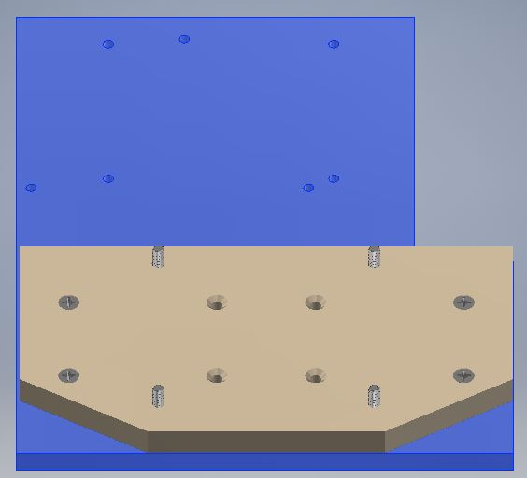Attach the 4 screws that pass through the shielding material to the baseplate using one of the two methods explained above. There should be no part of the screw that extends out from the baseplate on the opposite side.

**Step 4**

* Install the Spark Gap Shielding Top.
* Place the Spark Gap Shielding Top over the four screws and set this assembly aside in a safe area.

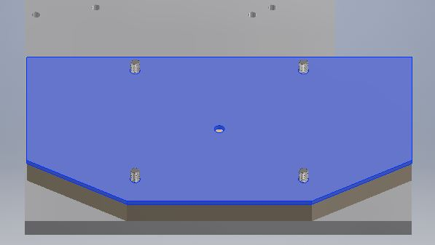

* The Spark Gap needs to be built at this point.
* Ensure that the insulation layers do not hit any of the screws and push them to an odd angle.
* The clamps used to secure the Spark Gap are fastened using the four screws sticking out of the top of the G10 shielding plates and need to be in the correct position to make the clamp installation easy.

**Step 5**

* Building the electrode assembly
* Gather the 2 electrodes, 2 inner baffles and 2 outer baffles.
* Insert the electrode into the inner baffle. The large ring section of the electrode should be towards the front of the inner baffle as shown in the picture.

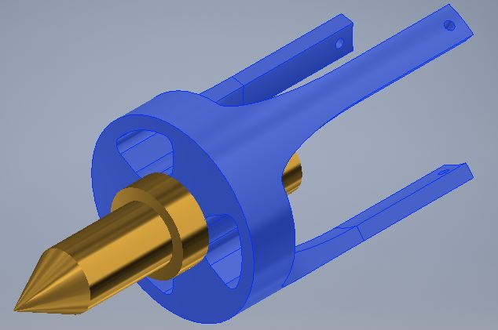

**Step 6**

* Now connect the two wires that will go to the transformer to the two electrode assemblies by inserting them through the center of the outer baffle and inserting it into the back recess of the electrode. The wires should be around 6”. The wire should be ran through the set screw hole (opposite direction of red arrow) of the electrode and through the center of the set screw and out of the head of the screw

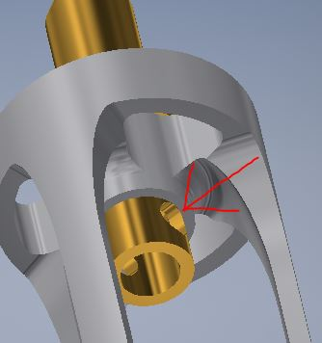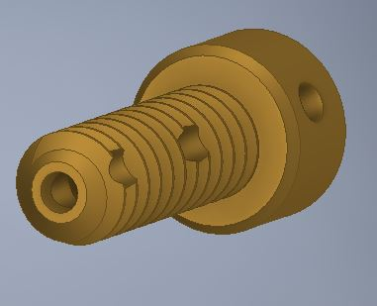

**Step 7**

* Install set screw with wire inside
* Connecting the baffles
* Insert the outer inner baffle and electrode into the outer baffle. The three prongs of the inner baffle line up with holes in the outer baffle. The holes in the pongs of the inner baffle should be visible on the opposite face of the outer baffle.
* Run thin wire through the small holes in the inner baffle to hold the assembly together
* Solder the wire to the set screw at the screw head.

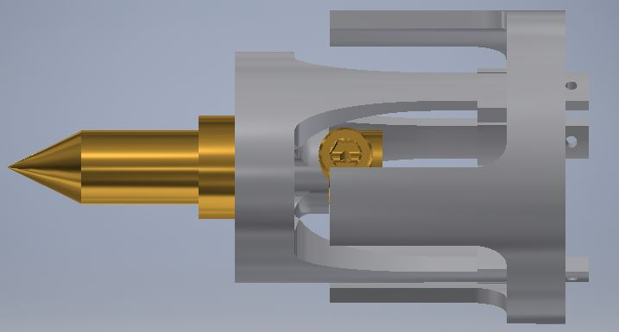

**Step 8**

* Wrap Quartz Tube in aluminum foil and .0625” Viton.
* Take a small piece of aluminum foil make sure it is flat and completely wrap the quartz tube leaving the ends open.
* Once the foil wrap is on the tube, wrap the Viton around the tube. The Viton should have the view window precut. You can use electrical tape to hold the Viton together around the tube. Now remove the foil from the viewing window using a tool that will not scratch the quartz tube. (I used my fingernail)

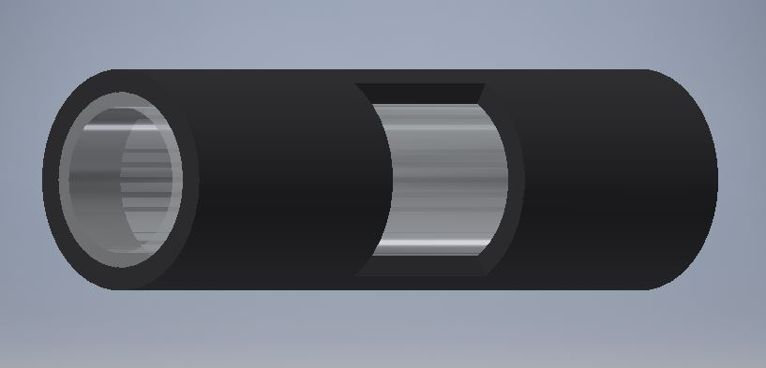

**Step 9**

* Install the electrode assemblies into the quartz tube.
* Insert the electrode assembly into the quart tube until the inner baffle is flush with the end of the quartz tube.
* The outer baffle prongs should go on the outside of the quartz tube and on the inside of the Viton.
* Be careful not to damage the foil wrap inside the Viton. This is difficult to accomplish but if it is damaged it is not critical to operation

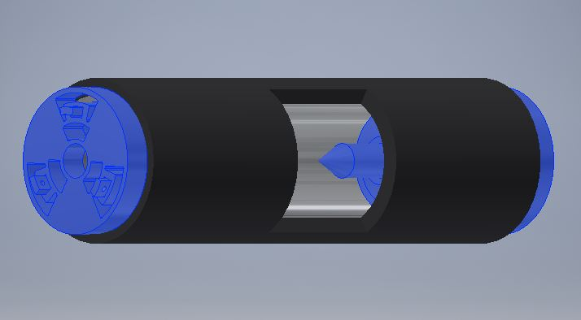

**Step 10**

* Wrapping the Spark Gap in Mesh Shielding
* Cut a 6”-7” length of the wire mesh shielding.
* Insert the Spark Gap Assembly into the mesh shielding making sure about 1.5” hangs over each end of the Spark Gap.

**Step 11**

* Mounting the Spark Gap to the G10 shielding
* Place the Spark Gap you just assembled and place it on the G10 Shielding assembly completed in Step 4.
* Make sure the viewing window is level and facing away from the side of the G10 with chamfered corners.
* Place 2 clamps over the Spark Gap. They should fit over the four screws sticking out of the shielding.
* Using 4 91828A211 M3 hex nuts, install the clamps. The clamps should have a very snug fit and the Spark Gap should not move when the nuts are fully tightened.
* The images below do not show the wires attached in prior steps just the orientation of the Spark Gap on the base plate.

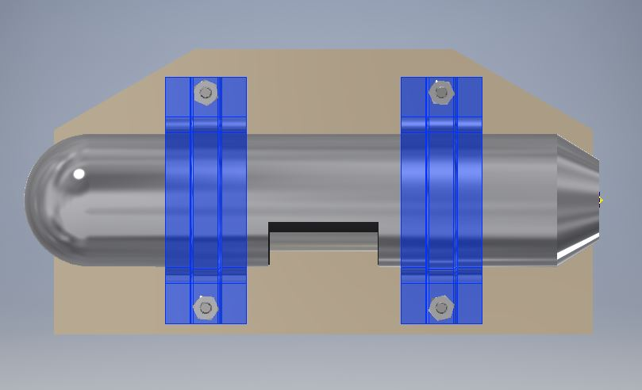

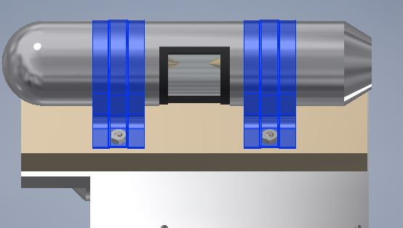

**Step 12**

* Wiring the transformer and the spark gap together.
* Install ferrite chokes on both sides of the transformer.
* Before connecting the wires between the transformer and the spark gap cut a length of the wire mesh shielding long enough to cover the wires between the two devices and slide it over the end of the wires of the transformer.
* Solder together the two leads from the spark gap to the two leads of the transformer making sure the transformer steps up the voltage to the spark gap.
* Extend the wire mesh shielding to cove the wiring.

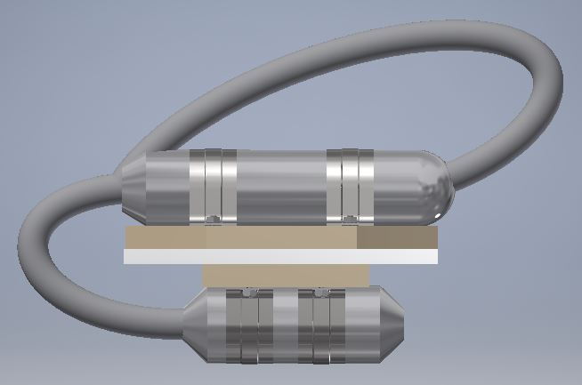

# Part VI

# Final Assembly

**Step 1**

* Using FILL IN HARDWARE mount the Raspberry Pi on the Aether payload in the location detailed below.

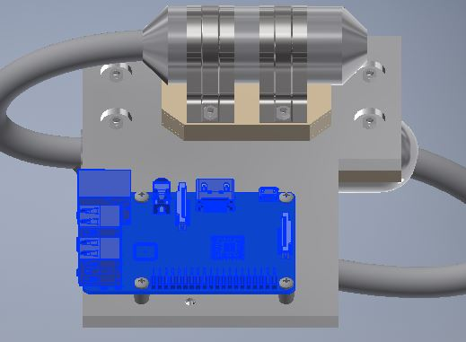

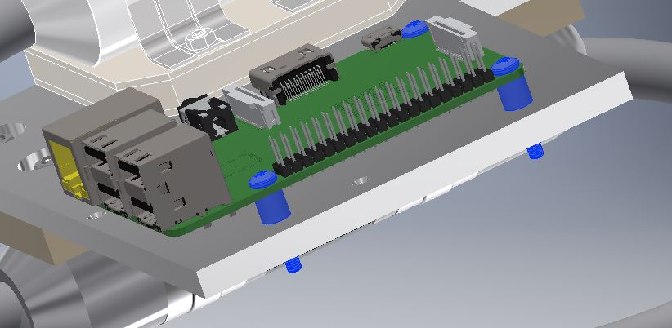

**Step 2**

* Using FILL IN HARDWARE mount the Raspberry Pi on the Aether payload in the location detailed below.
* The viewing window of the Spark Gap should line up with the camera of the Ocean Optic Spectroscopy Instrument.

*Note: It is very important that the two components line up properly to get accurate readings.*

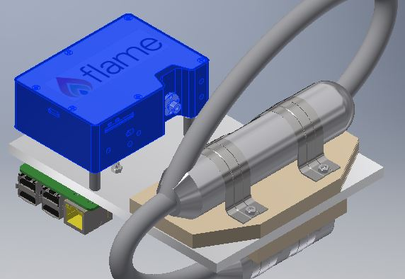

**Step 3**

* Connect your cables to the Raspberry Pi, Ocean Optics Flame and the Transformer

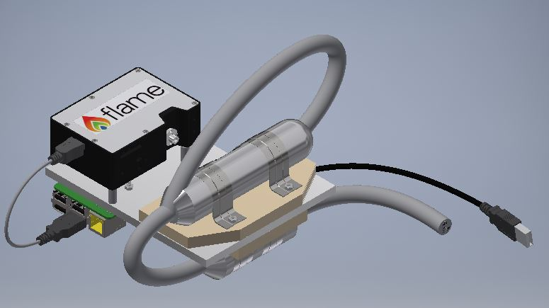

**Step 4**

* Insert the Camera Shroud Tube into the Camera Shroud Mount as shown in the image below.

PICTURE

* Attach the Camera Shroud Mount to the Aether box wall using FILL IN HARDWARE as shown below.

PICTURE

* Extend the Camera Shroud Tube out (like a telescope) until its curve fits snuggly over the spark gap’s window.

PICTURE

* Secure the Camera Shroud Tube in place by inserting a set screw into the Camera Shroud Mount and tightening

PICTURE

# Part VII

# Shop Drawings

# Part VIII

# Setting Up the Raspberry Pi

This section will explain how to set up a Raspberry Pi to operate the Ocean Optics Flame Spectrometer. It assumes one already has a Raspberry Pi 3+ running Raspbian Stretch Lite. A basic familiarity with Linux as well as an understanding of basic Linux console commands (specifically: $mv, $cp, $rm, $mkdir, & $unzip) is necessary here. All referenced files are included in the same Github repository as this document (UMBC_DPLX_SPARK_2018).

1. Place the file “seabreeze-3.0.11.zip” in the directory /home/pi/Documents
2. Unzip the file
3. Run the command $sudo apt-get install libusb-dev
4. Locate the file “10-oceanoptics.rules” inside of /home/pi/Documents/seabreeze-3.0.11/SeaBreeze/os-support/linux and copy it to the directory /lib/udev/rules.d
5. Locate the file “Log.cpp” in /home/pi/Documents/seabreeze-3.0.11/SeaBreeze/src/common and delete this file
6. Place the “Log.cpp” file included with this document in the same folder where the faulty “Log.cpp” was just deleted
7. Place the file “demo-getSpectrumLoop.c” in the directory /home/pi/Documents/seabreeze-3.0.11/SeaBreeze/sample-code/c
8. Inside of /home/pi/Documents create two new directories called “Data_Files” and “codeTesting”
9. Place the files “sparkGapOff.py” and “sparkGapOn.py” in the directory /home/pi/Documents/codeTesting
10. While inside of the /home/pi/Documents/codeTesting directory, run the command $sudo chmod +x sparkGapOff.py and $sudo chmod +x sparkGapOn.py
11. Move to the directory /home/pi/Documents/seabreeze-3.0.11/SeaBreeze and run the command $make (note: this step can take anywhere from 10 to 30 minutes)
12. Within the directory /home/pi/Documents/seabreeze-3.0.11/SeaBreeze/lib locate the file “libseabreeze.so” and copy it to the directory /lib/arm-linux-gnueabihf

**The Raspberry Pi Software**

Assuming the above instructions have been followed, the spark gap’s flight software has been set up on the Raspberry Pi. When run, this software will infinitely request new back to back spectrums from the spectrometer, storing these spectrums in text files within the /home/pi/Documents/Data_Files directory. Each text file will be titled “SpecData_[number].txt”. For every other spectrum, the program will also toggle one of the Raspberry Pi’s GPIO pins high to serve as a potential trigger to activate the spark gap or other light source should one desire. The default integration time is 3.5 seconds and the default trigger GPIO pin is 26, however both of these values can be changed by altering the program settings that can be found in the header of the file demo-getSpectrumLoop.c (note that after each edit, $make will need to be run in the directory /home/pi/Documents/seabreeze-3.0.11/SeaBreeze/sample-code/c). To run the program, simply use the command $./demo-getSpectrumLoop while in the /home/pi/Documents/seabreeze-3.0.11/SeaBreeze/sample-code/c directory.

NOTE: If at any time the $./demo-getSpectrumLoop command fails, try appending “sudo” to the front of the command and running it again. For reasons not entirely clear, this is necessary on some Raspberry Pi’s but not others, even when they were supposedly set up identically.

# Part IX

# Manufacturing

|  |  |  |  |
| --- | --- | --- | --- |
| **Parts** | **Tools Used** | **Method** | **Notes** |
| Electrode Holders | SLA Printer  Sandpaper  Swiss Files | Precise sanding/filing may be required to remove excess print resin and ensure good fit inside of quartz tube | Manufactured at UMBC  Due to quartz tube tolerance, baffles may need sanding for good fit |
| Standoffs (for Pi) | Saw  Drill Press | Use saw to cut Delrin to length  Use drill press to cut hole for the screw  Can also be turned on lathe | Delrin Piece ordered from McMaster  Screw diameter = 0.086" |
| Base Plate | Milling Machine | Manual milling or CNC milling required | CNC Milling recommended due to part complexity and tolerance requirements |
| G10 | Laser Cutter | Machine it or laser cut, depending on thickness | Used 3 smaller laser cut sheets made by hand |
| Viton for transformer | X-ACTO knife | Cut with X-ACTO knife | Trim excess once installed |
| Electrodes for Spark Gap | Machined | Turned from round stock on lathe | Manufactured at UMBC |
| Wire Mesh | Tin snips | Compress to size of transformer to increase the diameter and decrease the length.  (Do this before cutting for better fit) | Wear Gloves (Safety Concern for metal splinters) |
| Clamps | Vice  Drill Press  Hacksaw | There are ridges on both ends of clamps. Take the vice and tighten to make it flat. Once flat, position it on the pre-cut G10 and mark where the holes should be located on the G10. Use drill to cut 5/32-inch holes. | Take a hacksaw and cut of the excess |
| Camera Shroud Mount | Lathe  Milling Machine | FILL IN | FILL IN |
| Camera Shroud Tube | Lathe  Milling Machine | FILL IN | FILL IN |

# Part X

# Testing

All testing of the spark gap flight model was done in the lab model configuration using the separate testing rig that was assembled for lab and vacuum chamber use. Details on that configuration and the testing conducted with it can be found in the SPARK_Assembly_Instructions document included with this document.